VISVESVARAYA TECHNOLOGICAL UNIVERSITY
“JnanaSangama”, Belgaum- 590014, Karnataka.

LAB RECORD
on
Big Data Analytics (23CS6PCBDA)
Submitted by

THANMAY K H (1WA23CS018)

in partial fulfillment for the award of the degree of
BACHELOR OF ENGINEERING
in
COMPUTER SCIENCE AND ENGINEERING



B.M.S. COLLEGE OF ENGINEERING
(Autonomous Institution under VTU)
BENGALURU - 560019
February 2025 – July 2025

B.M.S. College of Engineering
Bull Temple Road, Bangalore 560019
(Affiliated to Visvesvaraya Technological University, Belgaum)

Department of Computer Science and Engineering


CERTIFICATE

This is to certify that the Lab work entitled “Big Data Analytics” carried out by Thanmay K H(1WA23CS014), who is bonafide student of B.M.S. College of Engineering. It is in partial fulfilment for the award of Bachelor of Engineering in Computer Science and Engineering of the Visvesvaraya Technological University, Belgaum during the year 2026. The Lab report has been approved as it satisfies the academic requirements in respect of a Big Data Analytics (23CS6PCBDA) work prescribed for the said degree.

Leethavathi
Assistant Professor Department of CSE, BMSCE

Dr. Kavitha Sooda
Professor & HOD Department of CSE, BMSCE

INDEX

Sl.  No. | Date | Experiment Title | Page No.
1 | 02.02.26 | MongoDB- CRUD Operations Demonstration (Practice and Self Study) | 1
2 | 09.02.26 | Perform the following DB operations using Cassandra.  - Create a keyspace by name Employee  - Create a column family by name  - Employee-Info with attributes  - Emp_Id Primary Key, Emp_Name, Designation,  - Date_of_Joining, Salary, Dept_Name  - Insert the values into the table in batch  - Update Employee name and Department of EmpId 121  - Sort the details of Employee records based on salary  - Alter the schema of the table Employee_Info to add a column Projects which stores a set of Projects done by the corresponding Employee.  - Update the altered table to add project names.  - Create a TTL of 15 seconds to display the values of Employees. | 4
3 | 16.02.26 | Perform the following DB operations using Cassandra.  - Create a keyspace by name Library  - Create a column family by name Library-Info with attributes  - Stud_Id Primary Key,  - Counter_value of type Counter,  - Stud_Name, Book-Name, Book-Id,  - Date_of_issue  - Insert the values into the table in batch  - Display the details of the table created and increase the value of the counter  - Write a query to show that a student with  id 112 has taken a book “BDA” 2 times.  - Export the created column to a csv file  - g) Import a given csv dataset from local file system into Cassandra column family | 6
4 | 23.02.26 | Execution of HDFS Commands for interaction with Hadoop Environment. (Minimum 10 commands to be executed) | 9
5 | 09.03.26 | Implement Wordcount program on Hadoop framework | 11
6 | 16.03.26 | From the following link extract the weather data  https://github.com/tomwhite/hadoop-book/tree/master/input/ncdc/all  - Create a MapReduce program to find average temperature for each year from NCDC data set.  - b) find the mean max temperature for every month | 14

7 | 23.03.26 | For a given Text file, Create a Map Reduce program to sort the content in an alphabetic order listing only top 10 maximum occurrences of words. | 20
8 | 20.04.26 | Write a Scala program to print numbers from 1 to 100 using for loop. | 24
9 | 21.04.26 | Using RDD and FlatMap count how many times each word appears in a file and write out a list of words whose count is strictly greater than 4 using Spark. | 25
10 | 21.04.26 | Write a simple streaming program in Spark to receive text data streams on a particular port, perform basic text cleaning (like white space removal, stop words removal, lemmatization, etc.), and print the cleaned text on the screen. (Open Ended Question). | 27

Course Outcomes (COs):

Github link: https://github.com/thanmaykh/bda-
CO1 | Apply the concept of NoSQL, Hadoop or Spark for a given task
CO2 | Analyse big data analytics mechanisms that can be applied to obtain solution for a given problem.
CO3 | Design and implement solutions using data analytics mechanisms for a given problem.

LABORATORY PROGRAM – 1
MongoDB- CRUD Operations Demonstration (Practice and Self Study) Command and Output
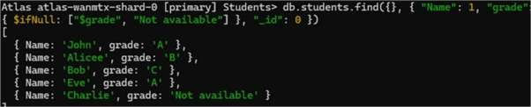

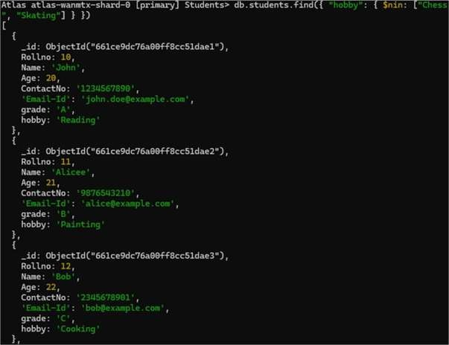

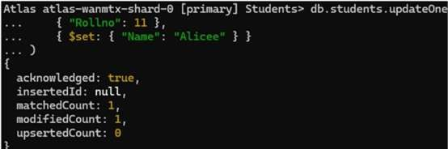

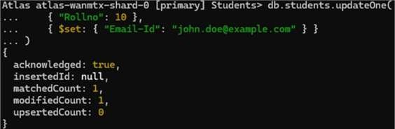

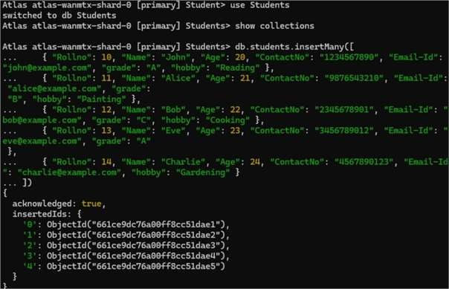

LABORATORY PROGRAM – 2
Perform the following DB operations using Cassandra
Questions:
- Create a keyspace by name Employee
- Create a column family by name
  - Employee-Info with attributes
  - Emp_Id Primary Key, Emp_Name,
  - Designation, Date_of_Joining,
  - Salary, Dept_Name
- Insert the values into the table in batch
- Update Employee name and Department of Emp-Id 121
- Sort the details of Employee records based on salary
- Alter the schema of the table Employee_Info to add a column Projects which stores a set of Projects done by the corresponding Employee.
- Update the altered table to add project names.
- Create a TTL of 15 seconds to display the values of Employees.

COMMAND WITH OUTPUT

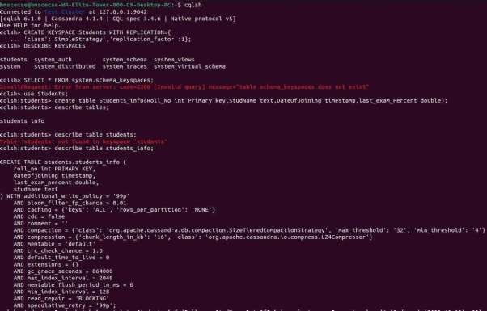

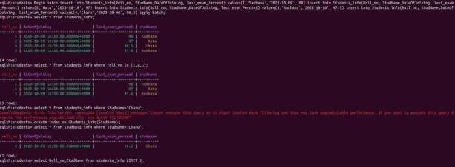

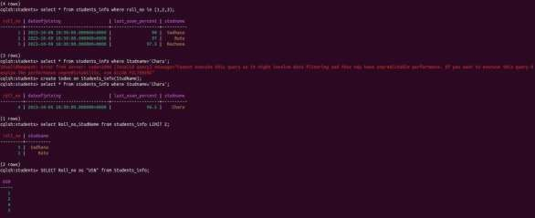

LABORATORY PROGRAM – 3
Perform the following DB operations using Cassandra
Questions:

- Create a keyspace by name Library
- Create a column family by name Library-Info with attributes
  - Stud_Id Primary Key,
  - Counter_value of type Counter,
  - Stud_Name, Book-Name, Book-Id,
  - Date_of_issue
- Insert the values into the table in batch
- Display the details of the table created and increase the value of the counter
- Write a query to show that a student with id 112 has taken a book “BDA” 2 times.
- Export the created column to a csv file
- Import a given csv dataset from local file system into Cassandra column family

COMMAND WITH OUTPUT

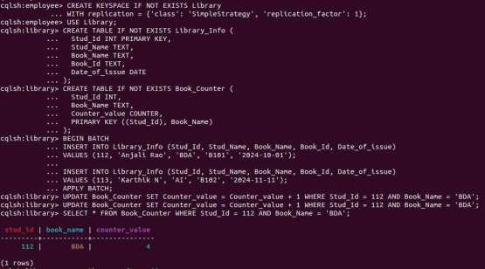

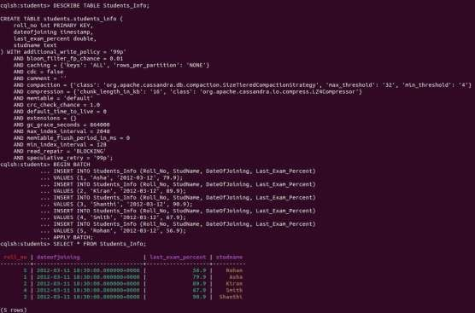

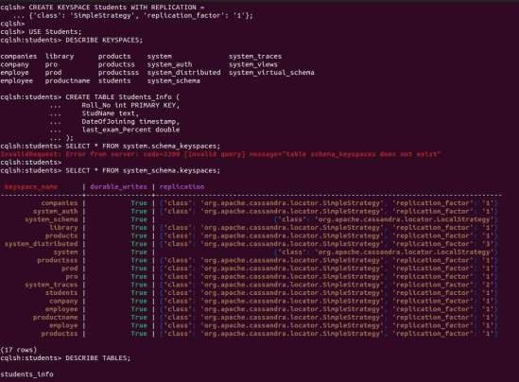

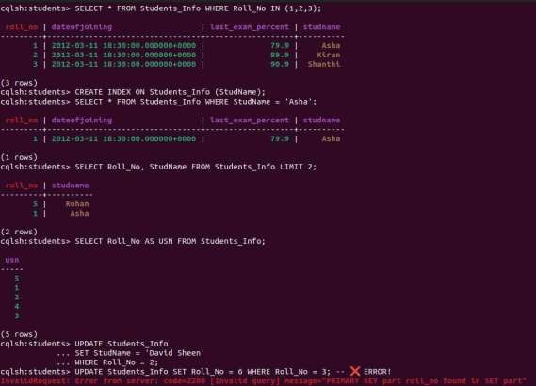
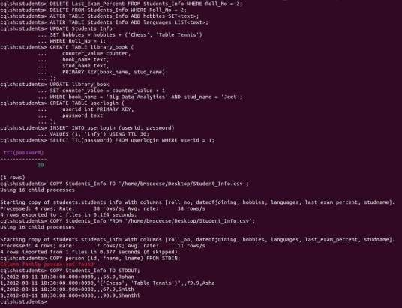

LABORATORY PROGRAM – 4
Execution of HDFS Commands for interaction with Hadoop Environment. (Minimum 10 commands to be executed)

COMMAND WITH OUTPUT
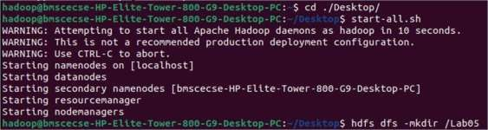
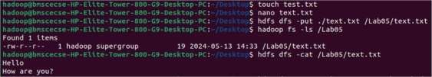
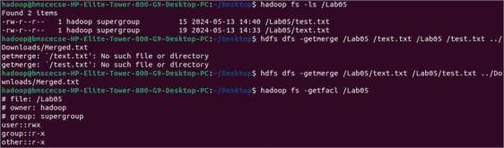
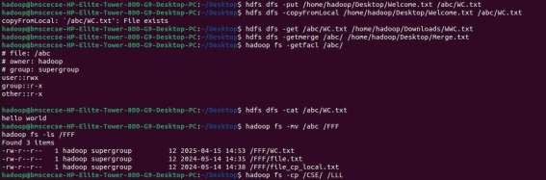

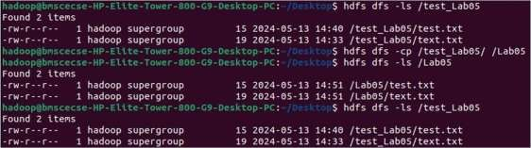

LABORATORY PROGRAM – 5
Implement Wordcount program on Hadoop framework
CODE
Driver Code

import org.apache.hadoop.conf.Configured; import org.apache.hadoop.fs.Path;
import org.apache.hadoop.io.IntWritable; import org.apache.hadoop.io.Text;
import org.apache.hadoop.mapred.FileInputFormat; import org.apache.hadoop.mapred.FileOutputFormat; import org.apache.hadoop.mapred.JobClient; import org.apache.hadoop.mapred.JobConf;
import org.apache.hadoop.util.Tool; import org.apache.hadoop.util.ToolRunner;
public class WCDriver extends Configured implements Tool {
public int run(String[] args) throws IOException { if (args.length < 2) {
System.out.println("Please give valid inputs"); return -1;
}
JobConf conf = new JobConf(WCDriver.class); conf.setJobName("WordCount");
FileInputFormat.setInputPaths(conf, new Path(args[0])); FileOutputFormat.setOutputPath(conf, new Path(args[1]));

conf.setMapperClass(WCMapper.class); conf.setReducerClass(WCReducer.class);

conf.setMapOutputKeyClass(Text.class); conf.setMapOutputValueClass(IntWritable.class);

conf.setOutputKeyClass(Text.class); conf.setOutputValueClass(IntWritable.class);

JobClient.runJob(conf); return 0;
}
// Main Method
public static void main(String[] args) throws Exception { int exitCode = ToolRunner.run(new WCDriver(), args); System.out.println("Job Exit Code: " + exitCode);
}
}

Mapper Code
// Importing libraries import java.io.IOException;
import org.apache.hadoop.io.IntWritable; import org.apache.hadoop.io.LongWritable; import org.apache.hadoop.io.Text;
import org.apache.hadoop.mapred.MapReduceBase; import org.apache.hadoop.mapred.Mapper;
import org.apache.hadoop.mapred.OutputCollector; import org.apache.hadoop.mapred.Reporter;

public class WCMapper extends MapReduceBase implements Mapper<LongWritable, Text, Text, IntWritable> {
// Map function
public void map(LongWritable key, Text value, OutputCollector<Text, IntWritable> output, Reporter reporter) throws IOException {
String line = value.toString();
// Splitting the line on whitespace for (String word : line.split("\\s+")) {
if (word.length() > 0) {
output.collect(new Text(word), new IntWritable(1));
}
}
}
}

Reducer Code
// Importing libraries import java.io.IOException; import java.util.Iterator;
import org.apache.hadoop.io.IntWritable; import org.apache.hadoop.io.Text;
import org.apache.hadoop.mapred.MapReduceBase; import org.apache.hadoop.mapred.OutputCollector; import org.apache.hadoop.mapred.Reducer;
import org.apache.hadoop.mapred.Reporter;
public class WCReducer extends MapReduceBase implements Reducer<Text, IntWritable, Text, IntWritable> {
// Reduce function
public void reduce(Text key, Iterator<IntWritable> values, OutputCollector<Text, IntWritable> output, Reporter reporter) throws IOException {
int count = 0;
// Counting the frequency of each word while (values.hasNext()) {
count += values.next().get();
}
output.collect(key, new IntWritable(count));
}
}

COMMAND WITH OUTPUT
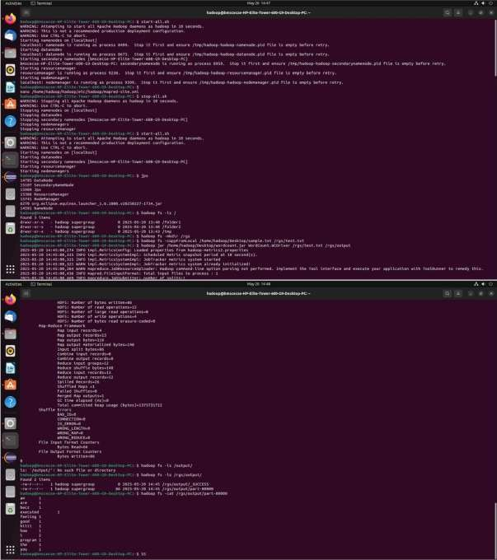

LABORATORY PROGRAM – 6
Implement Weather program on Hadoop framework

Questions:

From the following link extract the weather data https://github.com/tomwhite/hadoopbook/tree/master/input/ncdc/all
- Create a MapReduce program to find average temperature for each year from NCDC data set.
- find the mean max temperature for every month.

- CODE

import org.apache.hadoop.fs.Path;
import org.apache.hadoop.io.IntWritable; import org.apache.hadoop.io.Text;

import org.apache.hadoop.mapreduce.Job;
import org.apache.hadoop.mapreduce.lib.input.FileInputFormat; import org.apache.hadoop.mapreduce.lib.output.FileOutputFormat;
public class AverageDriver {
public static void main(String[] args) throws Exception { if (args.length != 2) {
System.err.println("Please enter both input and output parameters."); System.exit(-1);
}
// Creating a configuration and job instance Configuration conf = new Configuration();
Job job = Job.getInstance(conf, "Average Calculation"); job.setJarByClass(AverageDriver.class);
// Input and output paths FileInputFormat.addInputPath(job, new Path(args[0])); FileOutputFormat.setOutputPath(job, new Path(args[1]));
// Setting mapper and reducer classes job.setMapperClass(AverageMapper.class); job.setReducerClass(AverageReducer.class);
// Output key and value types job.setOutputKeyClass(Text.class); job.setOutputValueClass(IntWritable.class);

// Submitting the job and waiting for it to complete System.exit(job.waitForCompletion(true) ? 0 : 1);
}
}

import org.apache.hadoop.conf.Configuration;

Mapper Code
package temp;
import java.io.IOException;
import org.apache.hadoop.io.IntWritable; import org.apache.hadoop.io.LongWritable; import org.apache.hadoop.io.Text;
import org.apache.hadoop.mapreduce.Mapper;

public class AverageMapper extends Mapper<LongWritable, Text, Text, IntWritable> { public static final int MISSING = 9999;
@Override
public void map(LongWritable key, Text value, Context context) throws IOException, InterruptedException {
String line = value.toString();
// Extract year from fixed position String year = line.substring(15, 19); int temperature;
// Determine if there's a '+' sign if (line.charAt(87) == '+') {
temperature = Integer.parseInt(line.substring(88, 92));
} else {
temperature = Integer.parseInt(line.substring(87, 92));
}
// Quality check character
String quality = line.substring(92, 93);
// Only emit if data is valid
if (temperature != MISSING && quality.matches("[01459]")) { context.write(new Text(year), new IntWritable(temperature));
}
}
}

Reducer Code
package temp;
import java.io.IOException;
import org.apache.hadoop.io.IntWritable; import org.apache.hadoop.io.Text;
import org.apache.hadoop.mapreduce.Reducer;
public class AverageReducer extends Reducer<Text, IntWritable, Text, IntWritable> {
@Override
public void reduce(Text key, Iterable<IntWritable> values,
Context context) throws IOException, InterruptedException {
int sumTemp = 0; int count = 0;
for (IntWritable value : values) { sumTemp += value.get(); count++;
}
if (count > 0) {

int average = sumTemp / count; context.write(key, new IntWritable(average));
}
}
}

- COMMAND WITH OUTPUT
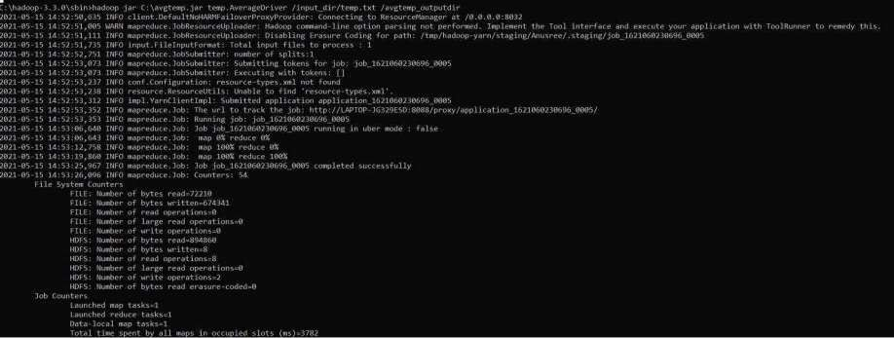

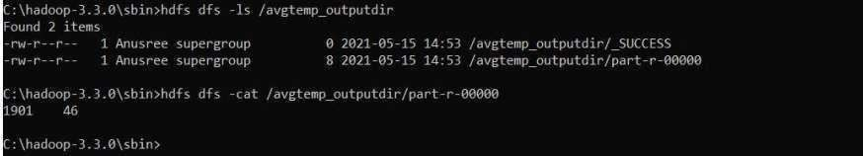

- Code
package meanmax;

import org.apache.hadoop.conf.Configuration; import org.apache.hadoop.fs.Path;
import org.apache.hadoop.io.IntWritable; import org.apache.hadoop.io.Text;
import org.apache.hadoop.mapreduce.Job;
import org.apache.hadoop.mapreduce.lib.input.FileInputFormat; import org.apache.hadoop.mapreduce.lib.output.FileOutputFormat;
public class MeanMaxDriver {
public static void main(String[] args) throws Exception { if (args.length != 2) {
System.err.println("Please enter both input and output parameters."); System.exit(-1);
}

Configuration conf = new Configuration();
Job job = Job.getInstance(conf, "Mean and Max Temperature"); job.setJarByClass(MeanMaxDriver.class);
FileInputFormat.addInputPath(job, new Path(args[0])); FileOutputFormat.setOutputPath(job, new Path(args[1]));
job.setMapperClass(MeanMaxMapper.class); job.setReducerClass(MeanMaxReducer.class);

job.setOutputKeyClass(Text.class); job.setOutputValueClass(IntWritable.class);
System.exit(job.waitForCompletion(true) ? 0 : 1);
}
}

Mapper Code
package meanmax;
import java.io.IOException;

import org.apache.hadoop.io.IntWritable; import org.apache.hadoop.io.LongWritable; import org.apache.hadoop.io.Text;
import org.apache.hadoop.mapreduce.Mapper;

public class MeanMaxMapper extends Mapper<LongWritable, Text, Text, IntWritable> { public static final int MISSING = 9999;
@Override
public void map(LongWritable key, Text value, Context context) throws IOException, InterruptedException {
String line = value.toString();
// Extract month from positions 19-20

String month = line.substring(19, 21); int temperature;

// Extract temperature considering optional '+' if (line.charAt(87) == '+') {
temperature = Integer.parseInt(line.substring(88, 92));
} else {
temperature = Integer.parseInt(line.substring(87, 92));
}
// Quality check
String quality = line.substring(92, 93);
if (temperature != MISSING && quality.matches("[01459]")) { context.write(new Text(month), new IntWritable(temperature));
}
}
}

Reducer Code
package meanmax;

import java.io.IOException;
import org.apache.hadoop.io.IntWritable; import org.apache.hadoop.io.Text;
import org.apache.hadoop.mapreduce.Reducer;
public class MeanMaxReducer extends Reducer<Text, IntWritable, Text, Text> { @Override
public void reduce(Text key, Iterable<IntWritable> values,
Context context) throws IOException, InterruptedException {
int sumTemp = 0; int count = 0;
int maxTemp = Integer.MIN_VALUE;
for (IntWritable value : values) { int temp = value.get(); sumTemp += temp;
count++;
if (temp > maxTemp) { maxTemp = temp;
}
}
if (count > 0) {
int avgTemp = sumTemp / count;
String result = "mean=" + avgTemp + " max=" + maxTemp; context.write(key, new Text(result));
}
}

- COMMAND WITH OUTPUT
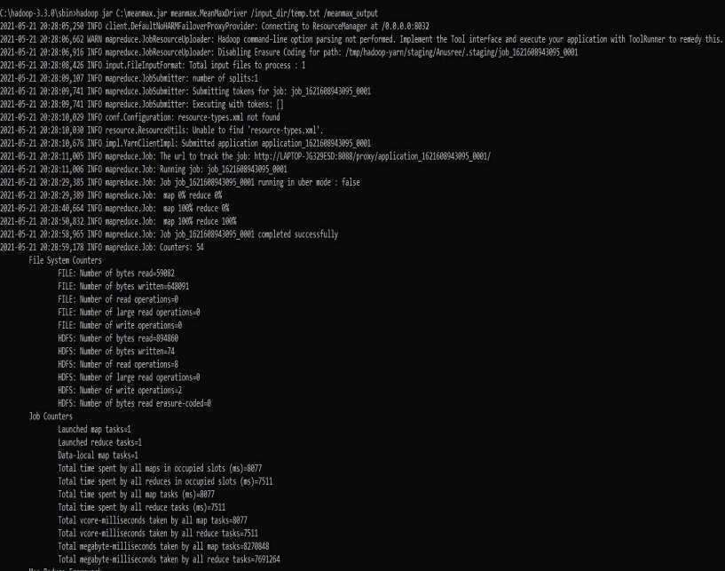

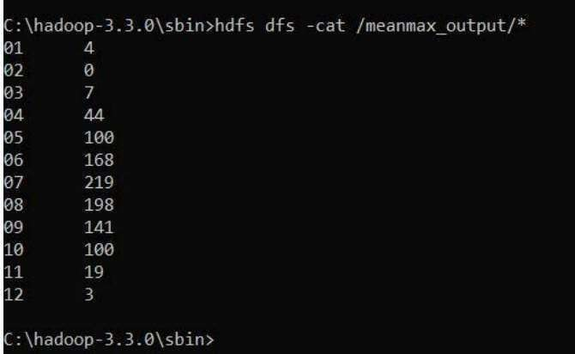

LABORATORY PROGRAM – 7
For a given Text file, Create a Map Reduce program to sort the content in an alphabetic order listing only top 10 maximum occurrences of words.

Code

package samples.topn;

import java.io.IOException; import java.util.StringTokenizer;

Mapper Code (WordCountMapper.java)

import org.apache.hadoop.io.IntWritable; import org.apache.hadoop.io.Text;
import org.apache.hadoop.mapreduce.Mapper;
public class WordCountMapper
extends Mapper<Object, Text, Text, IntWritable> {
private final static IntWritable ONE = new IntWritable(1); private Text word = new Text();
// characters to normalize into spaces
private String tokens = "[_|$#<>\\^=\\[\\]\\*/\\\\,;,.\\-:()?!\"']";
@Override
protected void map(Object key, Text value, Context context) throws IOException, InterruptedException {
// clean & tokenize
String clean = value.toString()
.toLowerCase()
.replaceAll(tokens, " "); StringTokenizer itr = new StringTokenizer(clean); while (itr.hasMoreTokens()) {
word.set(itr.nextToken().trim()); context.write(word, ONE);
}
}
}

Mapper Code (TopNMapper.java)
package samples.topn; import java.io.IOException;
import org.apache.hadoop.io.IntWritable; import org.apache.hadoop.io.Text;
import org.apache.hadoop.mapreduce.Mapper;
public class TopNMapper
extends Mapper<Object, Text, IntWritable, Text> {
private IntWritable count = new IntWritable(); private Text word = new Text();
@Override
protected void map(Object key, Text value, Context context) throws IOException, InterruptedException {

// input line: word \t count
String[] parts = value.toString().split("\\t");

if (parts.length == 2) { word.set(parts[0]); count.set(Integer.parseInt(parts[1]));
// emit count → word, so Hadoop sorts by count context.write(count, word);
}
}
}

Reducer Code (WordCountReducer.java)
package samples.topn; import java.io.IOException import org.apache.hadoop.io.IntWritable; import org.apache.hadoop.io.Text;
import org.apache.hadoop.mapreduce.Reducer;
public class WordCountReducer
extends Reducer<Text, IntWritable, Text, IntWritable> {
@Override
protected void reduce(Text key, Iterable<IntWritable> values, Context context) throws IOException, InterruptedException {
int sum = 0;
for (IntWritable val : values) { sum += val.get();
}
context.write(key, new IntWritable(sum)

Reducer Code (TopNReducer.java)
package samples.topn;
import java.io.IOException; import java.util.ArrayList; import java.util.Collections; import java.util.List; import java.util.Map; import java.util.TreeMap;

import org.apache.hadoop.io.IntWritable; import org.apache.hadoop.io.Text;
import org.apache.hadoop.mapreduce.Reducer;
public class TopNReducer
extends Reducer<IntWritable, Text, Text, IntWritable> {
// TreeMap with descending order of keys (counts) private TreeMap<Integer, List<String>> countMap =
new TreeMap<>(Collections.reverseOrder());
@Override
protected void reduce(IntWritable key, Iterable<Text> values, Context context) throws IOException, InterruptedException {
int cnt = key.get();
List<String> words = countMap.getOrDefault(cnt, new ArrayList<>()); for (Text w : values) {
words.add(w.toString());
}
countMap.put(cnt, words);
}
@Override
protected void cleanup(Context context) throws IOException, InterruptedException {

// collect top 10 word→count pairs List<WordCount> topList = new ArrayList<>(); int seen = 0;

for (Map.Entry<Integer, List<String>> entry : countMap.entrySet()) { int cnt = entry.getKey();
for (String w : entry.getValue()) { topList.add(new WordCount(w, cnt)); seen++;
if (seen == 10) break;
}
}

// sort these 10 entries alphabetically by word Collections.sort(topList, (a, b) -> a.word.compareTo(b.word));

// emit final top 10 in alphabetical order for (WordCount wc : topList) {
context.write(new Text(wc.word), new IntWritable(wc.count));
}
}
// helper class
private static class WordCount { String word;
int count;
WordCount(String w, int c) { word = w; count = c; }
}
}

COMMAND WITH OUTPUT
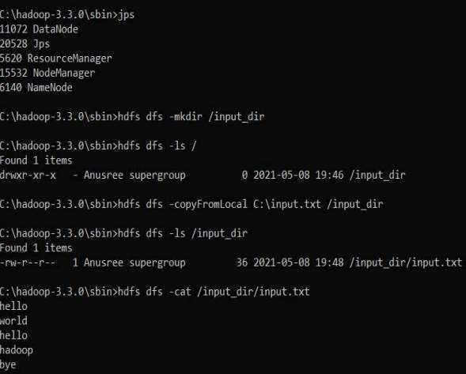

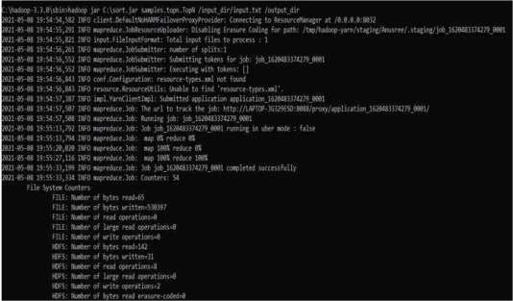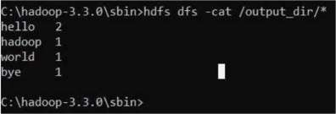

LABORATORY PROGRAM – 8
Write a Scala program to print numbers from 1 to 100 using for loop.

Code
object PrintNumbers {
def main(args: Array[String]): Unit = {

for (i <- 1 to 100) { println(i)
}
}
}

COMMAND WITH OUTPUT

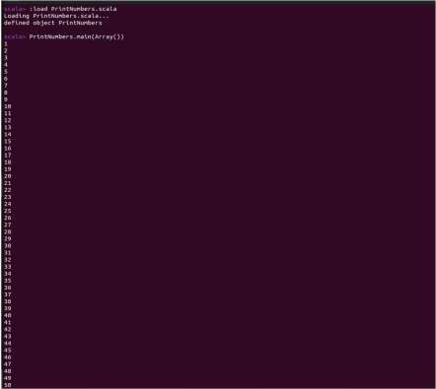

LABORATORY PROGRAM – 9
Using RDD and FlatMap count how many times each word appears in a file and write out a list of words whose count is strictly greater than 4 using Spark.

Code
from pyspark import SparkContext

# Create Spark Context
sc = SparkContext("local", "WordCountRDD")

# Load text file
# Replace 'input.txt' with your file path lines = sc.textFile("input.txt")

# Split lines into words using flatMap
words = lines.flatMap(lambda line: line.split())

# Map each word to (word, 1)
word_pairs = words.map(lambda word: (word.lower(), 1))

# Count occurrences of each word
word_counts = word_pairs.reduceByKey(lambda a, b: a + b)

# Filter words with count strictly greater than 4 filtered_words = word_counts.filter(lambda x: x[1] > 4)

# Collect and print results results = filtered_words.collect()

for word, count in results: print(word, count)

# Optional: save output to file filtered_words.saveAsTextFile("output")

# Stop Spark Context sc.stop()

COMMAND WITH OUTPUT

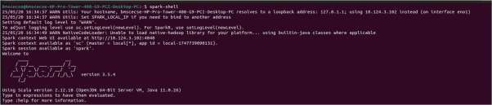

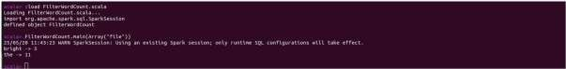

LABORATORY PROGRAM – 10
Write a simple streaming program in Spark to receive text data streams on a particular port, perform basic text cleaning (like white space removal, stop words removal, lemmatization, etc.), and print the cleaned text on the screen. (Open Ended Question).

Code
# Install NLTK and download required data (run once)
!pip install nltk

import nltk nltk.download('punkt') nltk.download('stopwords') nltk.download('wordnet')

from pyspark.sql import SparkSession
from pyspark.sql.functions import col, lower, regexp_replace, split, explode, udf from pyspark.sql.types import ArrayType, StringType
from pyspark.ml.feature import StopWordsRemover from nltk.stem import WordNetLemmatizer

# Initialize SparkSession
spark = SparkSession.builder.appName("TextProcessing").getOrCreate()

# Define your input lines lines = [
"Hello, I hate you.",
"I hate that I love you.", "Don't want to, but I can't put", "nobody else above you."
]

# Create DataFrame from lines
df = spark.createDataFrame(lines, "string").toDF("value")

# Step 1: Lowercase and remove punctuation
df_clean = df.select(regexp_replace(lower(col("value")), "[^a-zA-Z\\s]", "").alias("cleaned"))

# Step 2: Tokenize the cleaned text
df_tokens = df_clean.select(split(col("cleaned"), "\\s+").alias("tokens"))

# Step 3: Remove stop words
remover = StopWordsRemover(inputCol="tokens", outputCol="filtered") df_filtered = remover.transform(df_tokens)

# Step 4: Lemmatization using NLTK WordNetLemmatizer with UDF lemmatizer = WordNetLemmatizer()

def lemmatize_words(words):
return [lemmatizer.lemmatize(word) for word in words] lemmatize_udf = udf(lemmatize_words, ArrayType(StringType()))
df_lemmatized = df_filtered.withColumn("lemmatized", lemmatize_udf(col("filtered")))

COMMAND WITH OUTPUT

